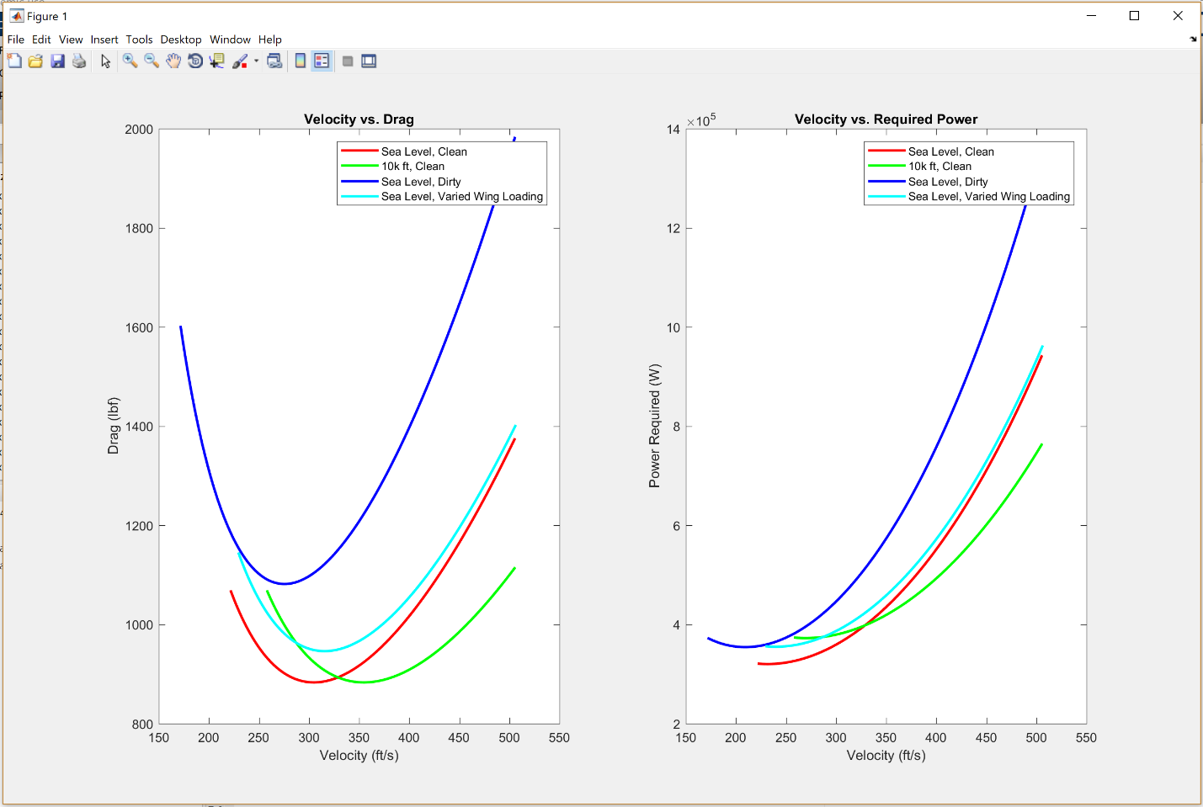

**Discussion and Observations of Graphs**…

On the topic of the drag polar: You can notice that the 10 thousand feet graph has a shallower tail than the graph of the baseline (clean, sea level). The varied wing loading graph has about the same length tail; in fact, it looks the most like the baseline graph in shape. The principle difference between the varied wing loading and baseline graphs are that the former looks like an upwards translation of the latter (hence the drag is always higher for the heavier wing loading, but the rate of changes for both are fairly similar). The dirty graph is the most exaggerated. For it, the drag is by far the largest of the three graphs, and the parabola’s trough is far deeper than the others as well.

For the graphs of power vs. velocity, you’ll notice that all three graphs require a similar amount of power at their respective stall velocities (and around that generally slow speed area of the graph) unlike the drag vs. velocity graphs where there are large differences between the drag experienced by each configuration at its respective stall velocity. It isn’t until the larger velocities that the distribution becomes more distinct. This may largely be due to the fact that due to the high stall velocities, the full parabolic shape of the graph can’t really be completely appreciated. As with the drag vs. velocity graph, the cruising altitude graph is the shallowest and the dirty graph is the most exaggerated. This leads to phenomena such as the following: The cruising altitude’s stall velocity requires the most power of the three, but its max velocity requires the least by far; the dirty graph has the second lowest minimum of the four graphs but by far the highest maximum; and so the phenomena go on.

You may also notice that we can see the difference in stall speeds for each of the conditions from these graphs. A baseline aircraft at cruising altitude has the highest stall velocity, which shouldn’t be worrying because planes will be flying much quicker at cruising height than at low altitudes near sea level. An aircraft in landing configuration also has the lowest stall velocity, which is ideal since you wouldn’t want a plane to stall out while it’s slowing down in preparation to land.

These are just a handful of observations you can make from the above graphs. There’s obviously a lot more to potentially discern beyond the aforementioned stuff.